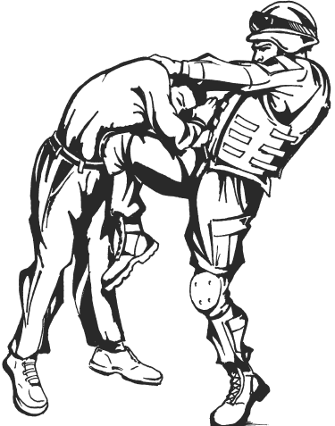
CERTIFICATE OF TRAINING

This is to certify that
ANTHONY SMITH JR.
has successfully completed the
TACTICAL COMBATIVES COURSE (80 hours)

07 – 18 March 2011
Given this 18th Day of March 2011

____________________ ____________________
MARC W. HICKEY JODY C. MILLER
SFC, USA LTC, IN
PRIMARY INSTRUCTOR COMMANDING

